



Trends Analysis

for Green Market Grocery



# Overview

In the past year, the grocery retail environment has changed dramatically. No longer can chains expect a solid 2–4 percent growth annually. Like other types of retail, consumer groceries are trying to stay steady in turbulent times. However, the best response now is innovation, not complacency. Unless companies like Green Market Grocery reconsider their strategies, the near future will be full of challenges, all of them difficult to overcome.

This report identifies the major trends for grocery retail in the coming year and offers insight into how Green Market Grocery can take advantage of them to continue to grow and profit.

# Focus on Local and Fresh

Consumer attitudes and shopping behavior are undergoing a transformation. Consumers define value in new ways, including private or specialty labels and brands. They seek foods from local or regional sources and are eager to support small and medium-sized local producers. Today, small producers are netting more than 60 percent of the branded goods market.[1]

For Green Market Grocery, this consumer preference means stores will have to rotate produce, seafood, and other fresh foods more frequently to reflect local availability.

Consumers also show a preference for healthy, natural foods and those with minimal processing. Green Market Grocery already caters to these consumers in their front-of-store displays, which feature colorful produce in an attractive, inviting environment.

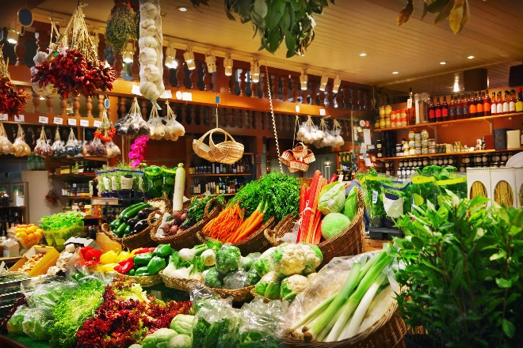

The challenge for Green Market Grocery will be to continue the seasonal, market-stand look throughout the store and figure out how to sell fresh food online, venue grocery shoppers are starting to use with increasing frequency.

# Online Grocery Shopping

Home-based digital assistants could have a major effect on grocery retail. From the comfort of their home or office, consumers can place orders for delivery using their digital assistants. The convenience is ideal for shoppers, but it leaves retailers feeling the pinch, even if consumers are ordering goods from their stores. Retailers are losing out on the impulse buys that pad grocery sales.

To stay competitive, traditional grocery stores can do the following:

* Add online shopping and delivery services.
* Devote more store space to the types of goods that drive consumers to the stores. 
  + Fresh and prepared foods
  + Specialty and local brands
* Host events for contemporary consumers.
  + Cooking demonstrations
  + In-house farmers markets

While investing in e-commerce and improved service models is a sound strategy, Green Market Grocery must determine whether they can avoid lowering their shelf prices. This puts pressure on the supply chain and the retailer to cut costs in other areas. The best way to combat the difficulties that come from reducing expenses is to align costs with growth opportunities so that expenses are investments rather than losses. In other words, stores should continue to fund the most profitable areas and cut back on marginal activities, even if they are in the traditional realm of grocery offerings.

Linda Somers writes in *Grocery Trends*, “One often overlooked advantage of online shopping is that consumers can easily access product information and compare prices. Providing these services in the store should be equally appealing.”

# In-Store Experiences

Along with addressing e-commerce innovations that offer consumers more ways to shop, grocery retailers can do more to attract shoppers to their physical stores.

***Payment*** ***services***: Consumers increasingly expect to pay for groceries using their smartphones. Stores should already be setting up mobile payment stations in checkout lanes.

***Dining***: Sampling stations offering hot and cold food are popular, as are cafés that provide coffee, tea, and other beverages along with a light lunch.

***Prepared and artisan foods***: If consumers switch to purchasing staples through e-commerce, stores can free shelf space for products shoppers find enticing or exciting. Local chefs demonstrating how to use local artisan foods is a winning activity in many locations.

***Sustainability***: Consumers want to know where their food comes from and how it was produced or grown. They prefer to find that information in the store rather than online. For example, some stores are displaying signs or maps indicating the number of miles a

# Subscription Meal Kits

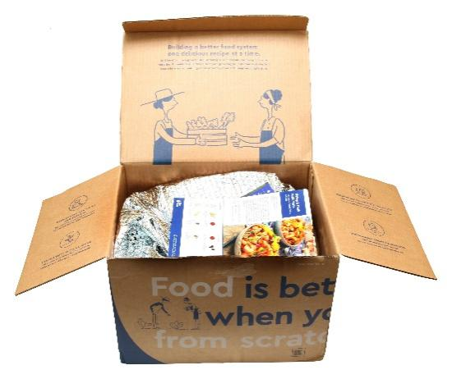While stand-alone companies popularized the trend of mail-order meal kits containing ingredients and recipes for a complete meal, grocery stores are starting to do the same. More food retailers will expand into meal kits, a $5 billion business last year.

Kits that focus on custom lifestyles, such as vegan and vegetarian meals, low-carbohydrate diet offerings, and healthy, garden-fresh options are growing in popularity. Other companies are offering theme kits, such as those featuring food of a certain region or country, and special recipes designed for kids.

# Research

Devon & Company conducted research to determine the state of the retail grocery business this year. In an online survey, we asked adults in the United States how they buy their groceries. About 990 people responded. Of the respondents, 92 percent buy their groceries in stores, down from 97 percent in the previous year.

|  |  |  |
| --- | --- | --- |
| **Grocery-shopping habits** | **Where they shop** | **Percentage (%)** |
| Delivery service | 8 |
| In stores | 92 |
| Mobile app | 6 |
| Online | 20 |
|  | Store pickup service | 10 |

We also asked U.S. adults how many trips they made to the grocery store each week. The following table compares the results to two previous years.

|  |  |
| --- | --- |
| **Year** | **Number of trips** |
| **2019** | 2.2 |
| **2020** | 1.8 |

Finally, we asked respondents to estimate their expenditures on the four most popular categories of grocery items in the past year. The following table shows the results.

|  |  |
| --- | --- |
| **Category** | **Expenditure ($)** |
| Bakery | 1,020 |
| Meat and seafood | 2,215 |
| Fresh produce and dairy | 910 |
| Packaged foods | 955 |
| Total | 5.100 |

For more survey results, contact [info@devon.cengage.com](mailto:info@devon.cengage.com)



Devon & Company Consultants ■devon.cengage.com

1. Small producers are those ranked below the 100 producers.